Walkthrough of the project

# Development of a simple Java application.

It is a calculator that is able to do the basic algorithm operations (e.g. addition, subtraction, multiplication and division). The chosen IDE is IntelliJ.

**Code:**

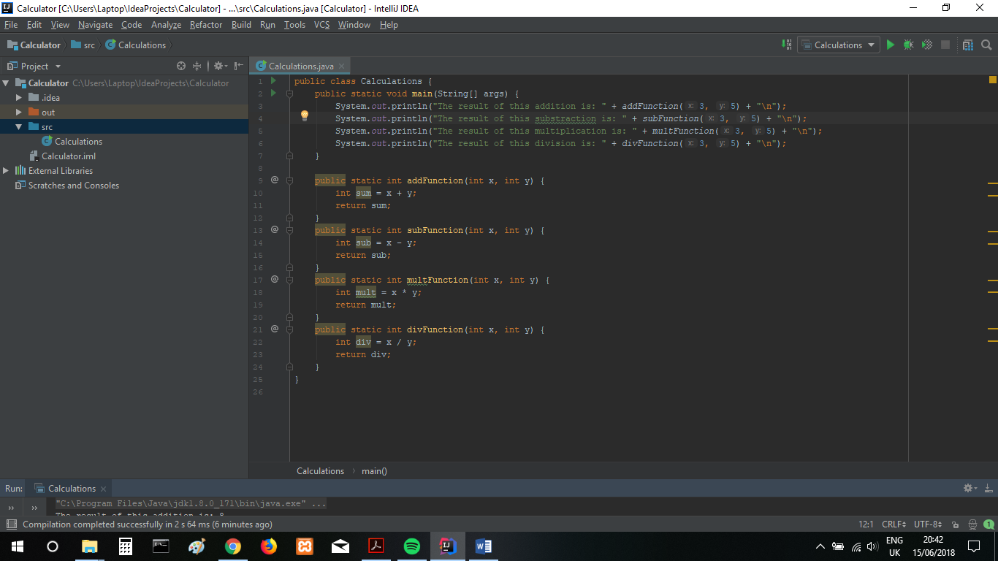

**Output:**

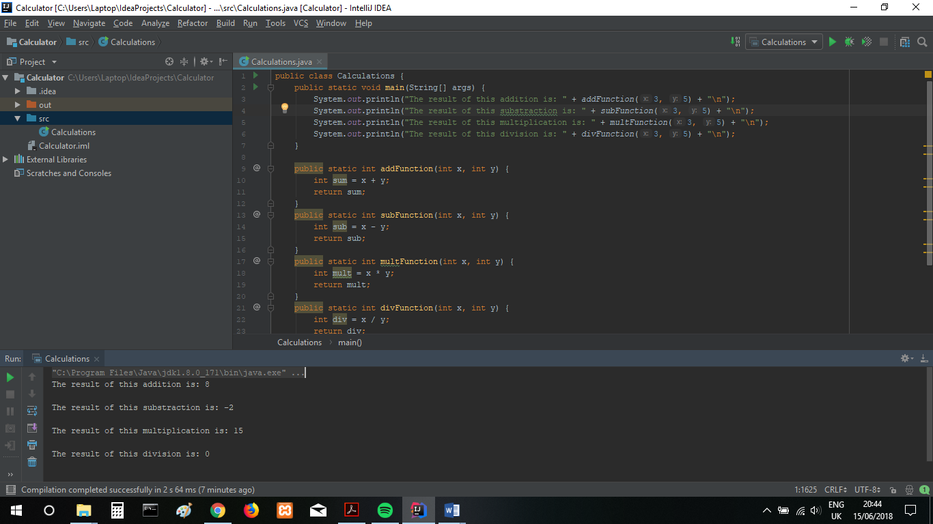

# Setting up VCS repository and pushing files to it

I chose Bitbucket because it is easy to use and it is popular amongst users and industries.  
I created a repository called Calc, and pushed the files to this repository via Git Bash.

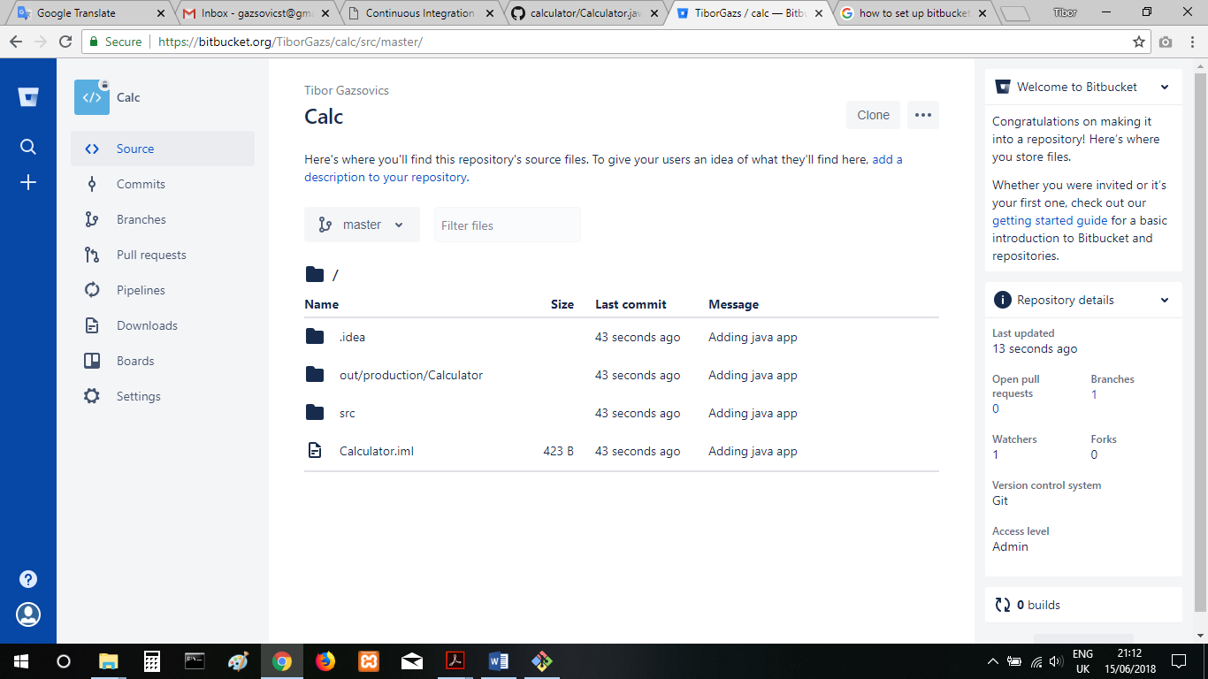

# Setting up Vagrant virtual machines (2)

First step was to initialise vagrant in a vagrant folder which created a folder and a vagrant file. An external virtual machine box was used. Created a shared folder and two Virtual machines, one is called machineA and the other one is machineB.

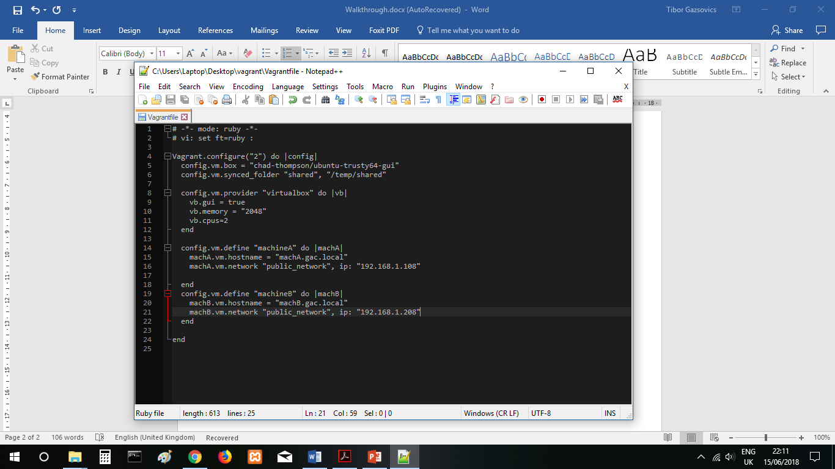

The outcome (left is machineA and the right is machineB)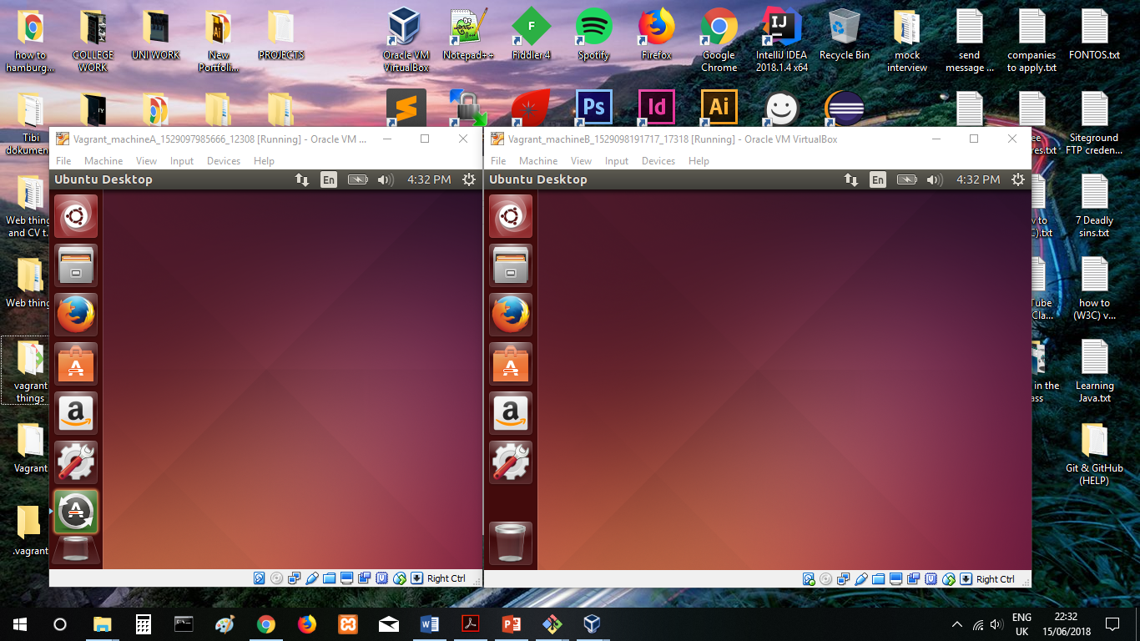

# Writing 2 bash scripts

The first script will install Java (ensuring that Java and Javac work) and Git on machine, and the other script will install Java, Git, Maven and Jenkins on the other VM.

First script outcome:

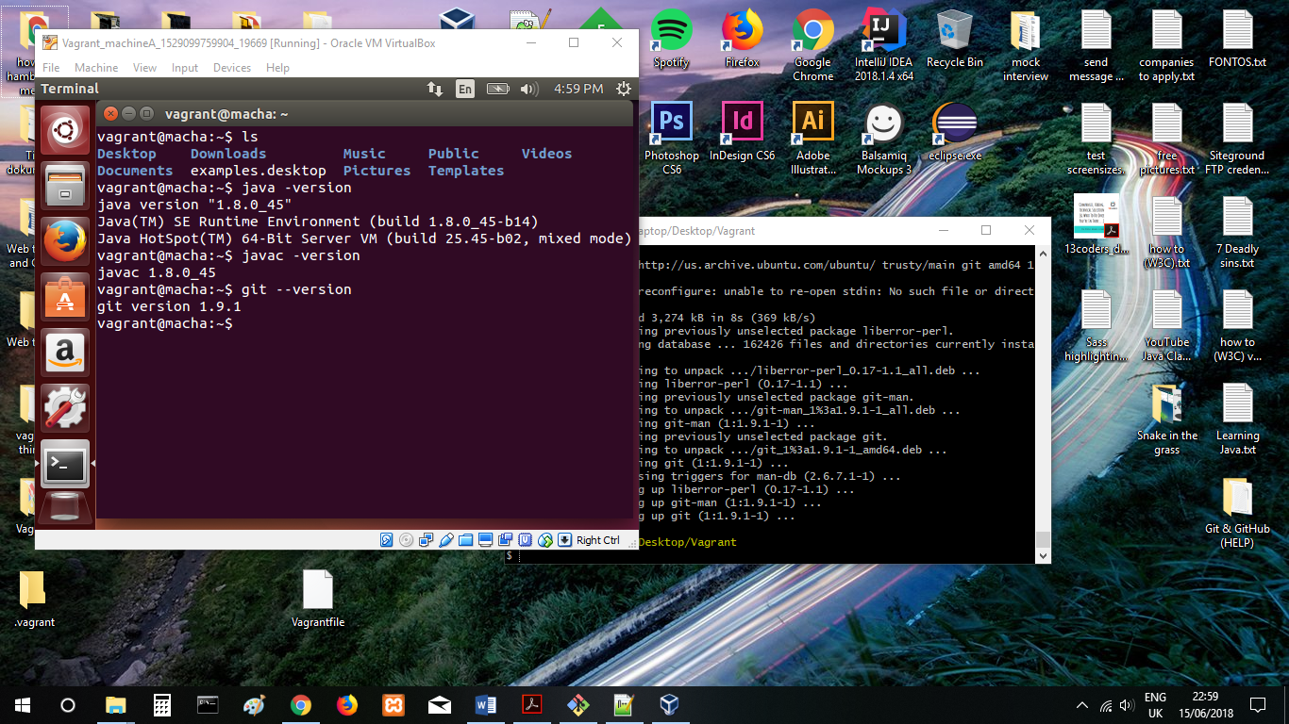

Second script outcome:

# Cloning the contents of the repository to machineA

VM MachineA will be used to create some scripts. However, when I opened Bitbucket on the VM it only showed a blank page.

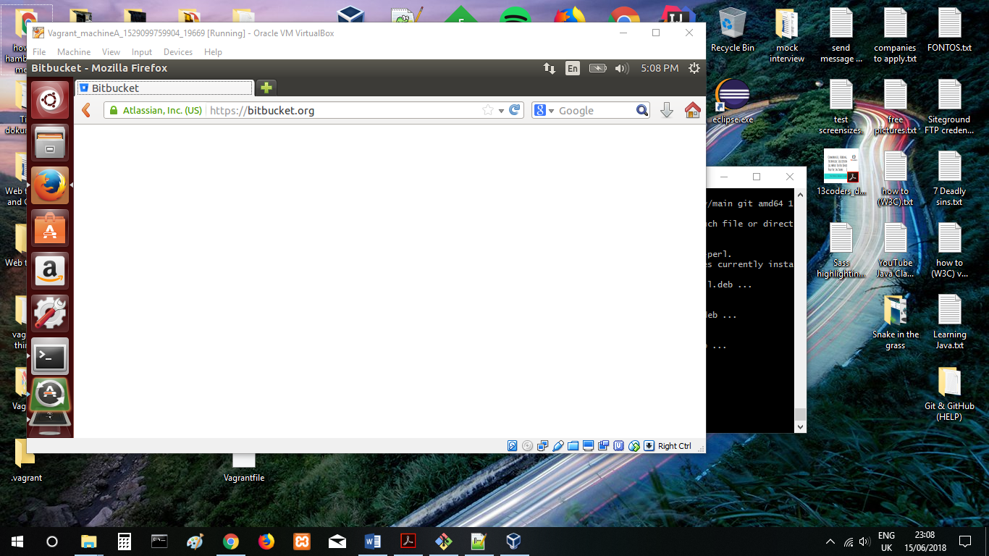

To counter the issue, I decided to use Github instead of Bitbucket.

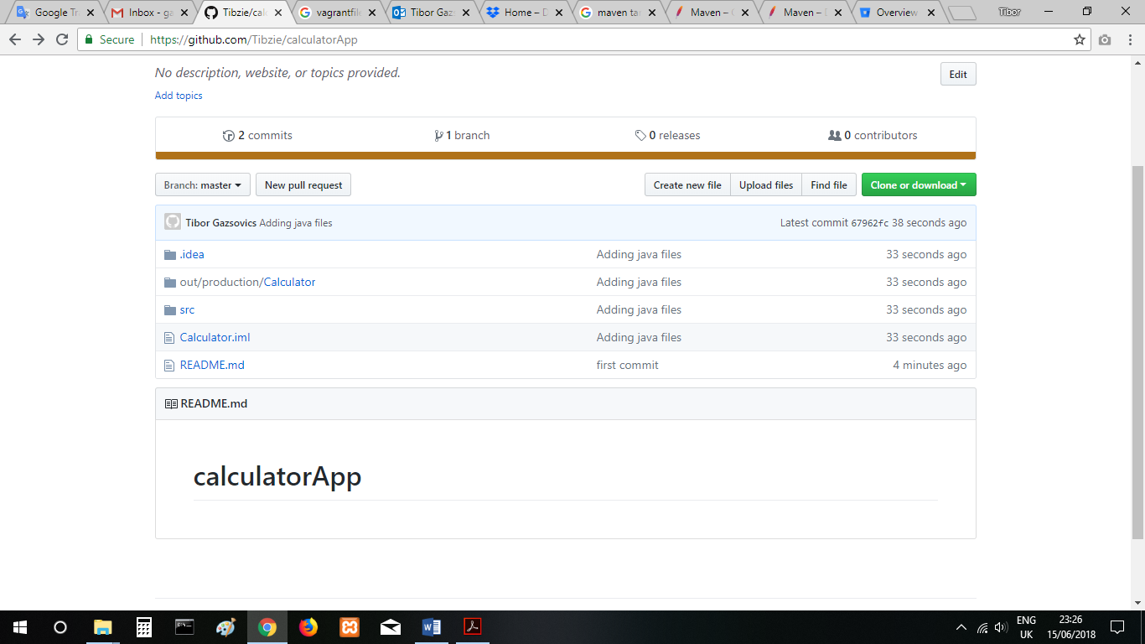

It was followed by cloning the contents to the Virtual machine to create two scripts.

# Creating two scripts

1. The first script shows the content of the current working folder which will be created as a file. Then, it’s copied to the /etc/ folder.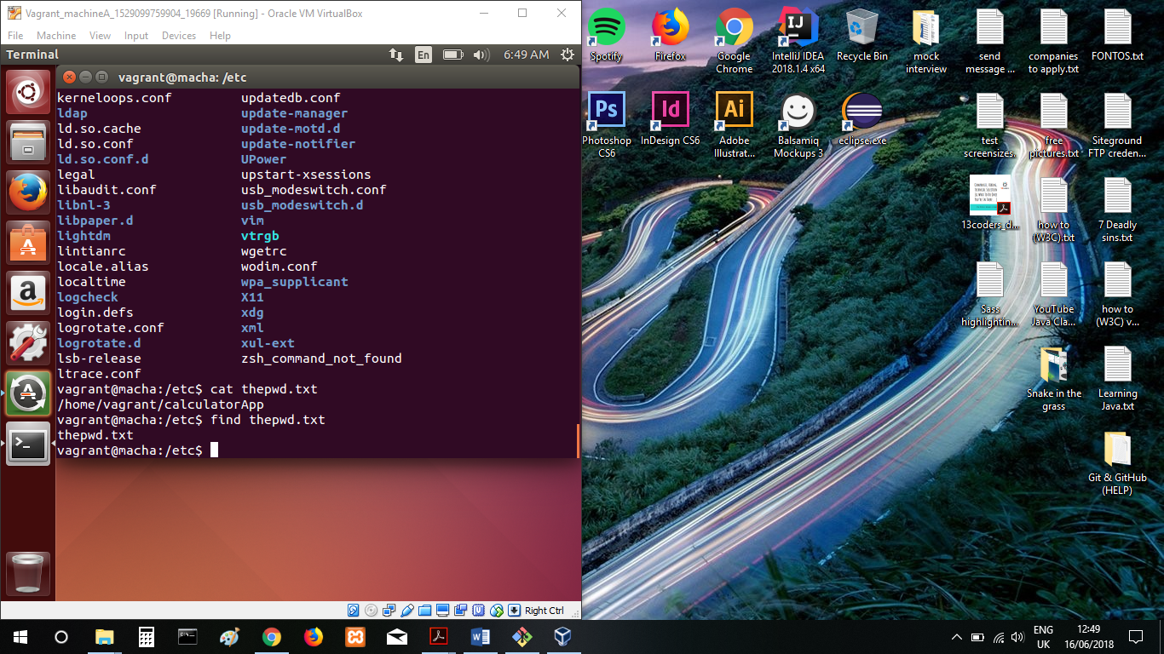
2. This script shows all logged in users on the VM and the IP address of the VM in a form of a file. The script also asks users if they want to delete existing log file if it exists.

First of all, listing the files.

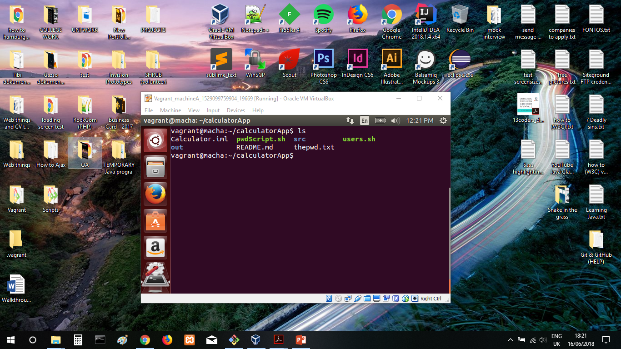

And then running the script, which will ask for user input (“y” or “n”). If the user types “n” then the file won’t get deleted and it will also respond to the input. It is followed by a “cat” command which shows what the file includes, as it shows it contains the logged in users and the IP address.

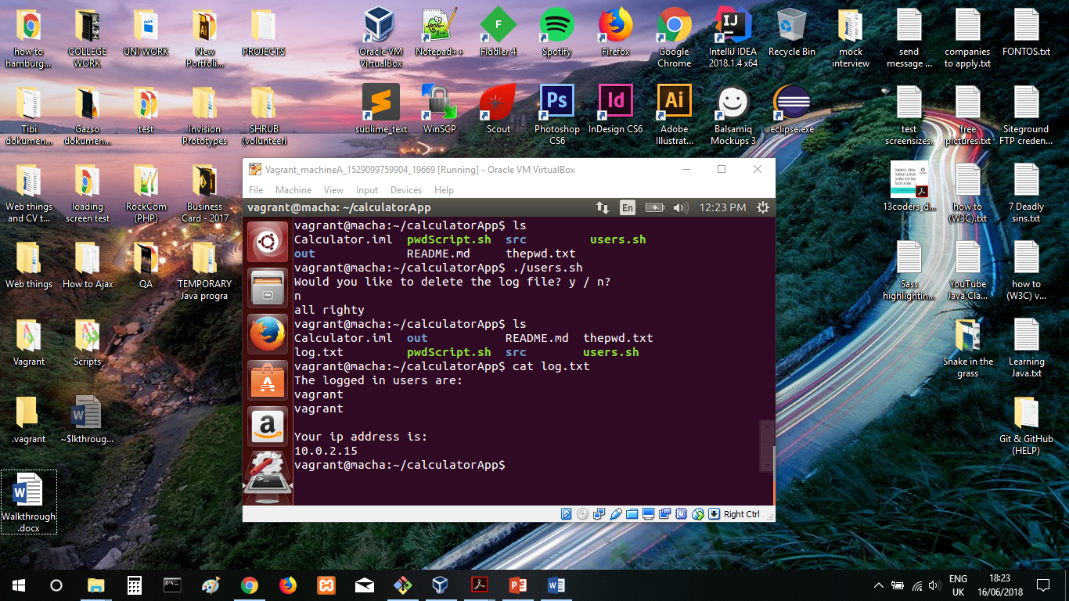

When the user inputs “y”. It deletes the log file as well as showing a message.

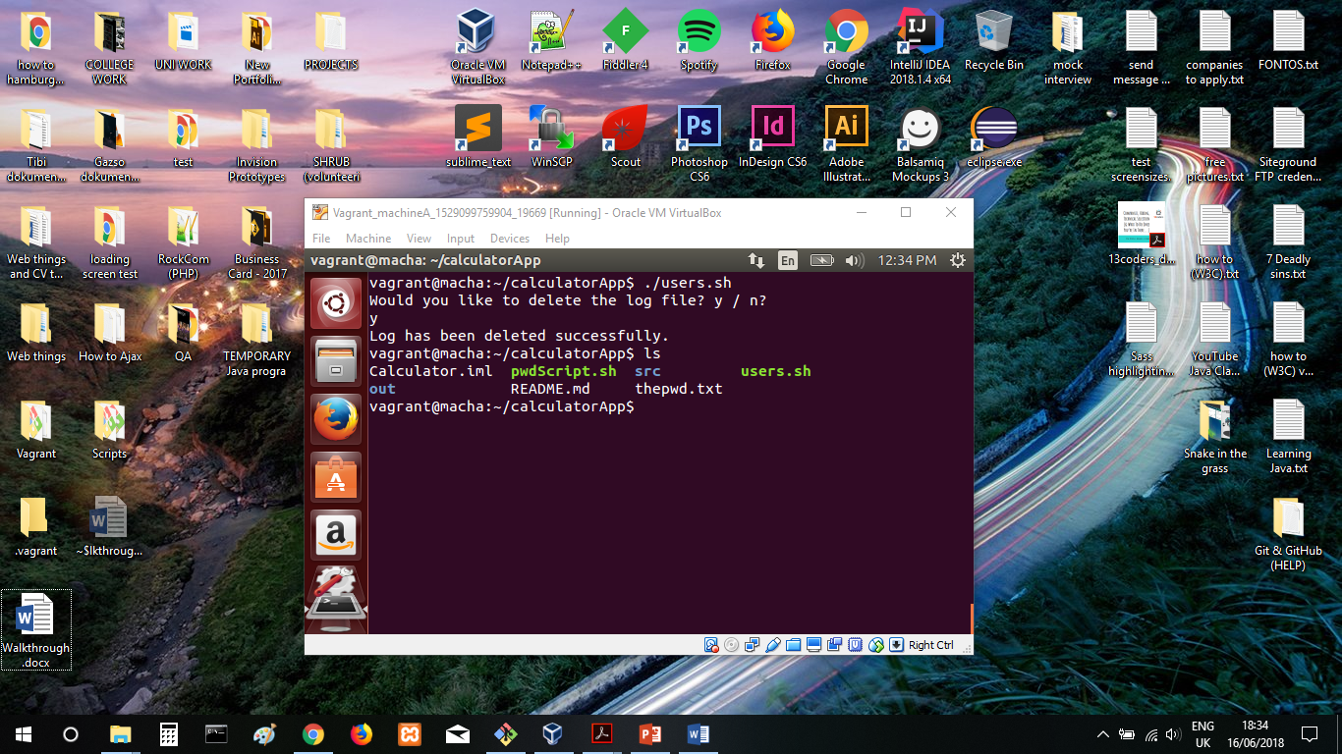

# Making a job through Jenkins that will build the Java application

